< Garrett Bachman >

< August 15 2021 >

< [IT FDN 110 B](https://canvas.uw.edu/courses/1474822) >

< Assignment 06 Knowledge Documentation >

Knowledge Documentation

Introduction

This document follows my process through module 6’s material and labs, as well as the final project at the end. This module revisits functions, and improves upon them with classes, returns, and parameters to help make our coding projects more organized.

[GitHub link](https://github.com/GarrettB123/Assignment_06)

Lab06-A

The beginning of the module reviewed functions, as well as introducing the use of parameters and return statements. The first lab uses an old assignment and adds in functions to make it more organized.

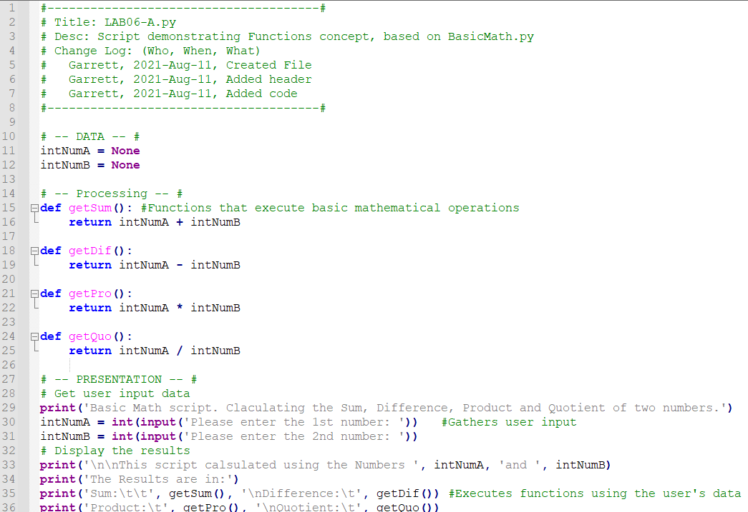

*Figure 1 - LAB06-A’s Code.*

This is the lab after running in the Anaconda Prompt

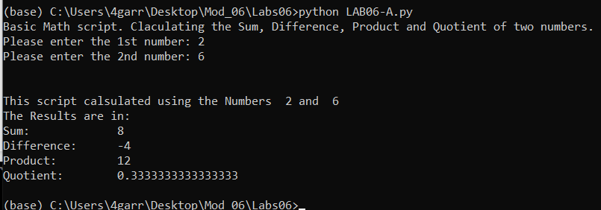

*Figure 2 - LAB06-A After Running in the Anaconda Prompt*

The program begins by asking the user for two numbers. The code then calls the previously defined functions and prints out the results.

Lab06-B

This next part of the module covered how to use multiple values in one return. This lab used lab A’s code and modified it so that there was only one function with one return instead of four of each.

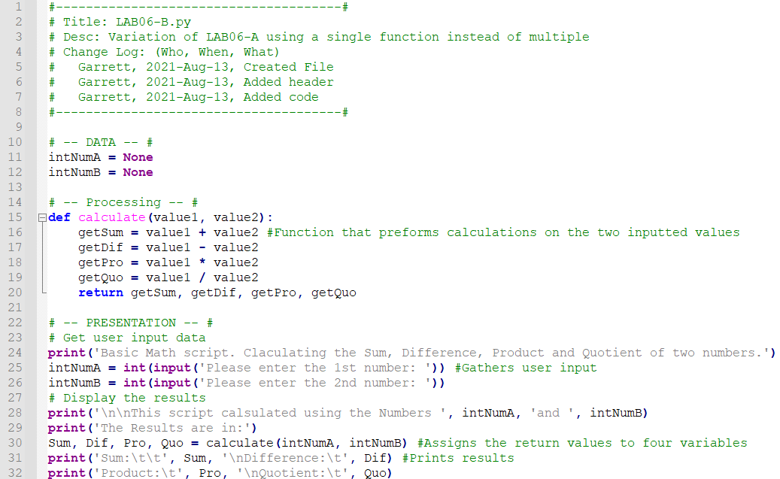

*Figure 3 - LAB06-B A’s Code.*

This is the program after running

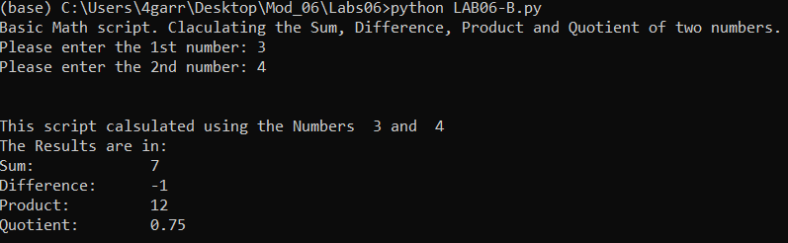

*Figure 4 - LAB06-B After Running in the Anaconda Prompt*

The code starts with getting the user input. The program then the user input as parameters while running the calculate function. The code assigns each return value to a matching variable, and prints the results.

Lab06-C

The third part of the module covered lots of things, such as overloaded functions and using classes. The lab used lab A’s code again, this time with the challenge of using a class.

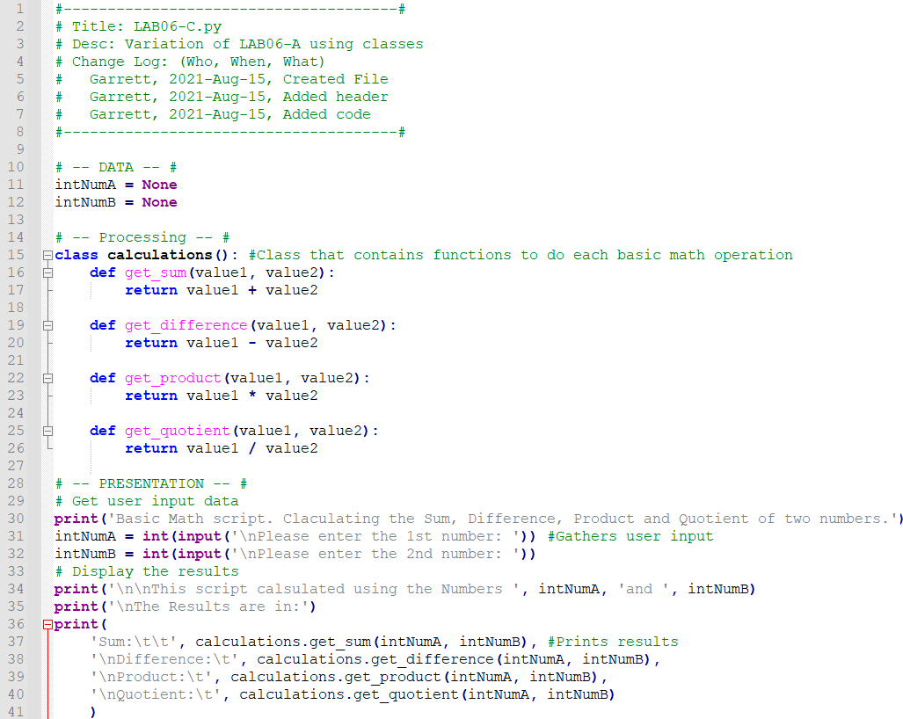

*Figure 5 - LAB06-B A’s Code.*

This is what the program looks like in the anaconda prompt

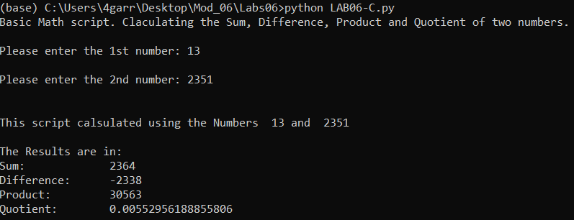

*Figure 6 - LAB06-B After Running in the Anaconda Prompt*

The program, like all the other labs in this module, starts with getting the user input. The program then uses the user input as parameters while running each function inside the class. The program then prints out the results.

Viewing Additional Content

This week, there was only one article to read. The article, [Functions](https://www.learnpython.org/en/Functions) (external reference)[1], reviewed the basics of making and calling functions.

Next up was the video. The video, [PYTHON FUNCTIONS (Beginner's Guide to Python Lesson 6)](https://www.youtube.com/watch?v=_ypAw_pCOt8) (external reference)[2], reviewed making and calling functions, as well as using parameters.

Applying my Knowledge

Once I was done with the rest of the stuff, I moved on to the assignment for this module. The assignment builds on last week’s assignment by organizing and adding lots of functions and classes.

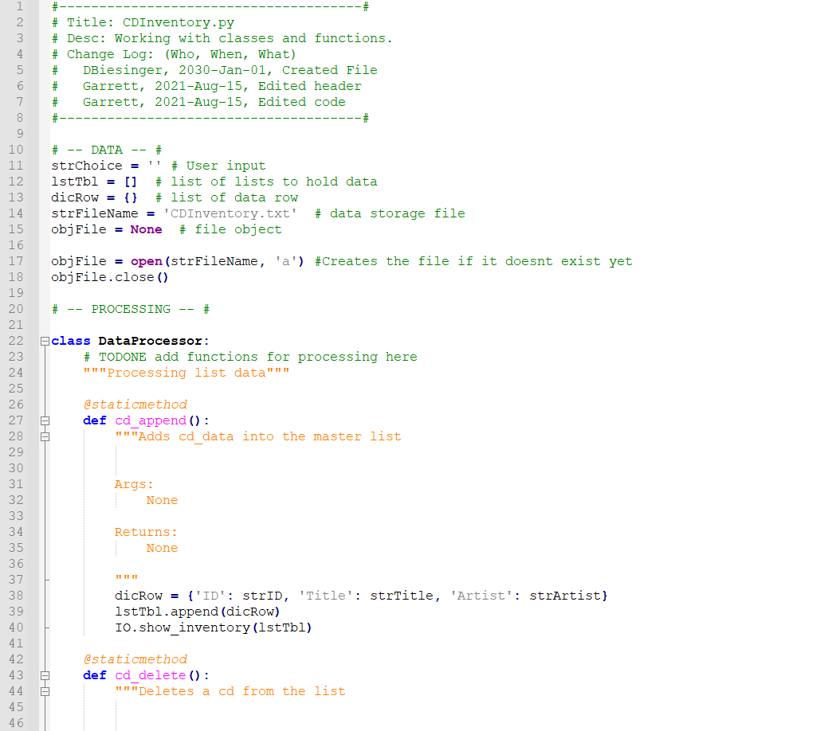

*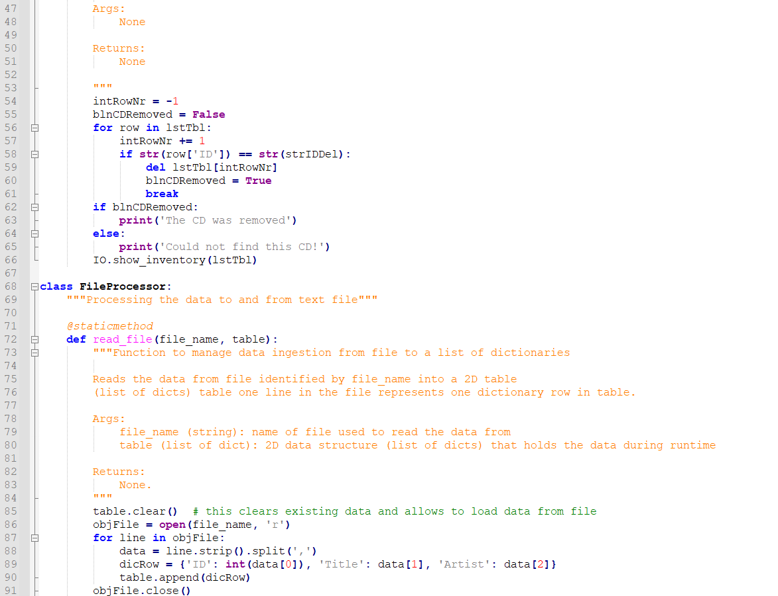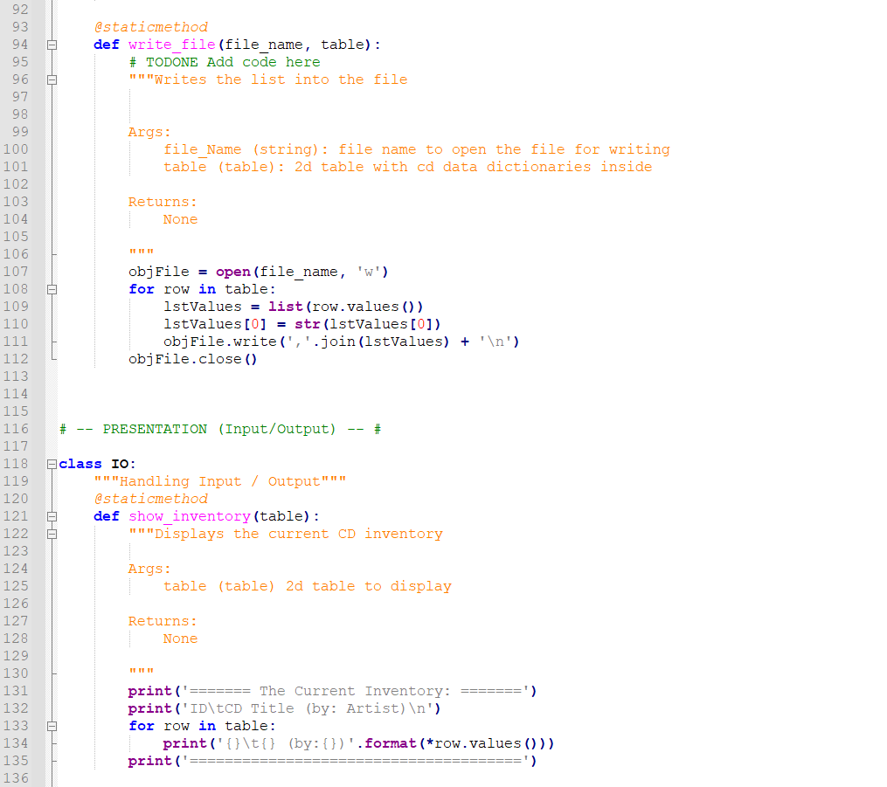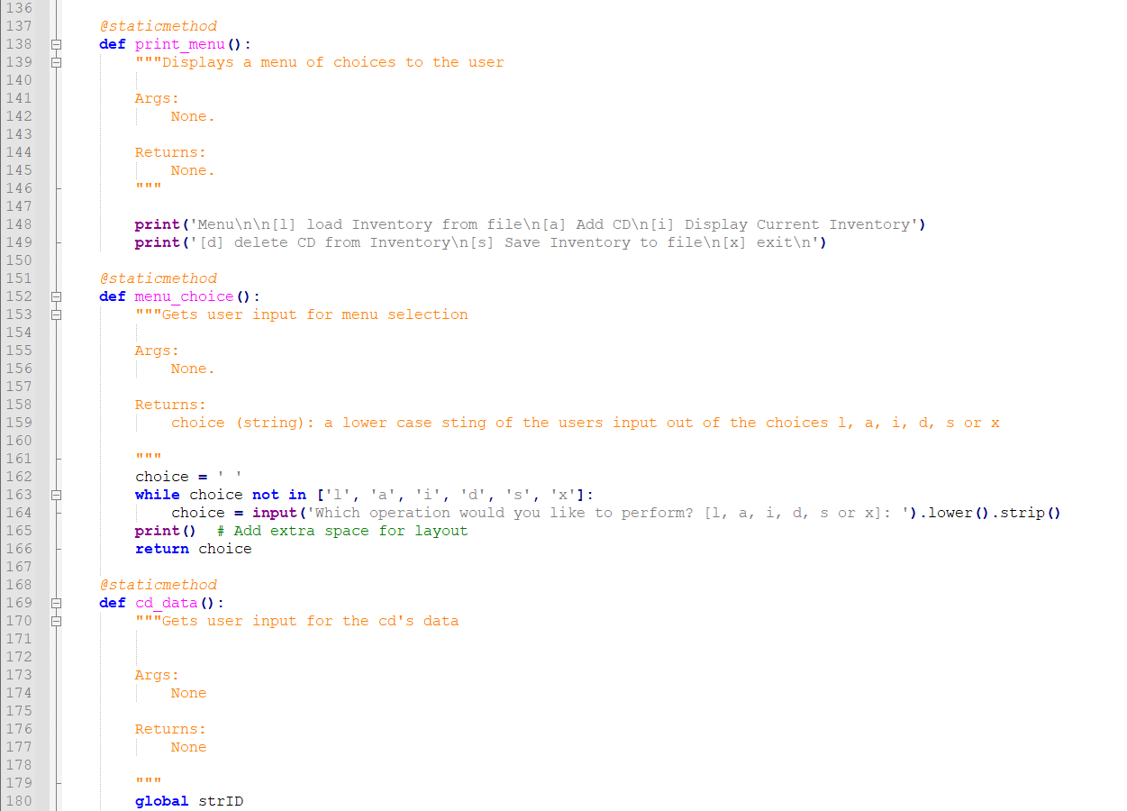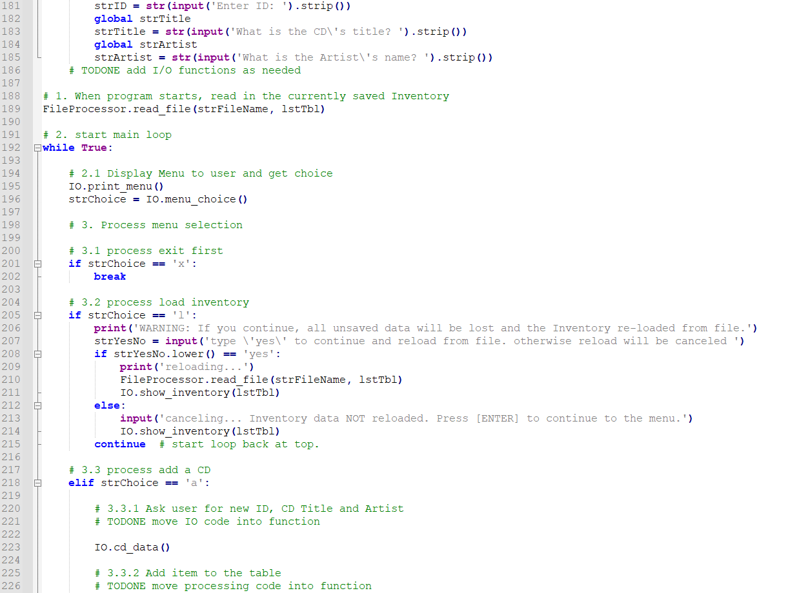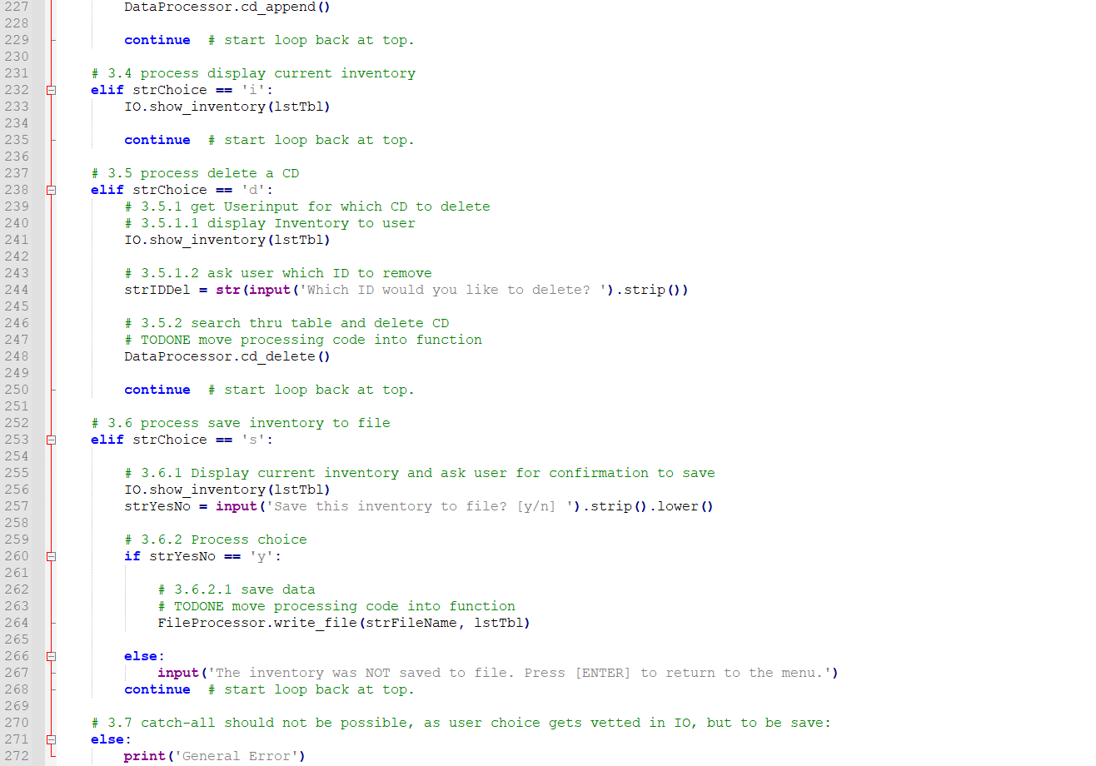Figure 7, 8, 9, 10, 11, 12 - CDInventory’s Code.*

This is the data I entered into the Anaconda Prompt:

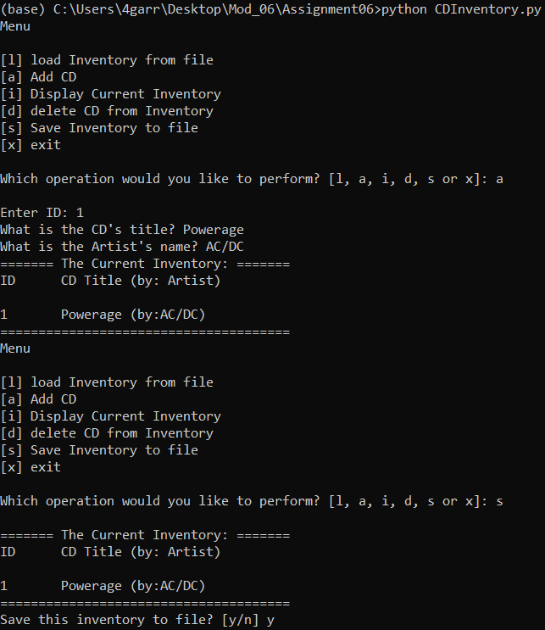

*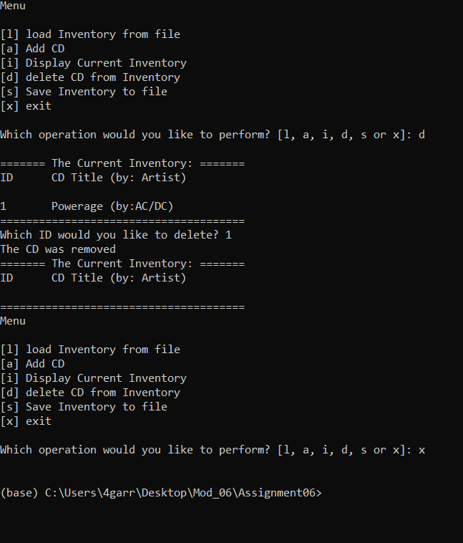Figure 13, 14 - CDInventory After Running in the Anaconda Prompt*

I didn’t demonstrate the loading function as there was nothing in the file beforehand so nothing would’ve happened. Anyways, here's the .txt file.

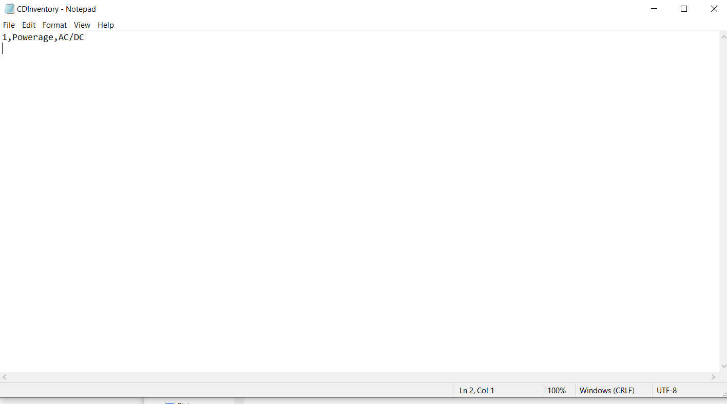

*Figure 15 - CDInventory.txt after I entered the data.*

The code organizes all of the main functions of the program into three classes: DataProcessor for manipulating the program’s lists and dictionaries, FileProcessor for sending and receiving data from the .txt file, and finally IO, which gathers user input and displays menus. Whenever one of the six options are chosen, the code runs a specified set of functions from various classes to carry out the user’s demand.

Summary

This module was very helpful for keeping our ever-enlarging code more organized, using classes and functions. Both classes and functions work together to help make the code easier to write and understand.

1. Retrieved August 15 2021
2. Retrieved August 15 2021